**TO OPEN WHATSAPP IN LAPTOP BROWSER**

1. Use below link to open WHATSAPP IN BROWSER

[**https://web.whatsapp.com/**](https://web.whatsapp.com/)

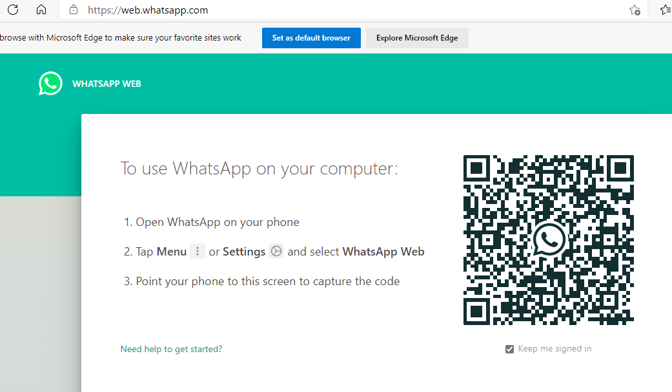

1. OPEN WHATSAPP IN MOBILE THEN CLICK ON **THREE DOTS SYMBOL** THEN CLICK ON **Linked devices**

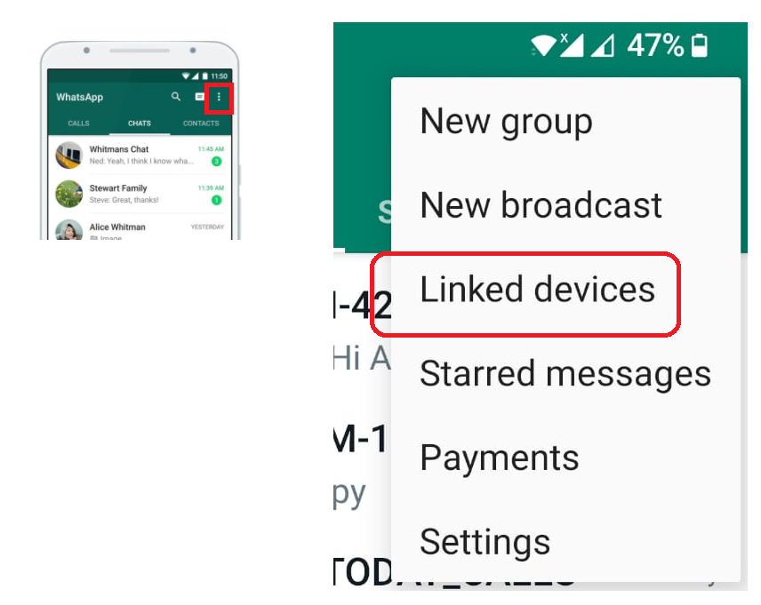

1. THEN CLICK ON **LINK A DEVICE** THEN SCAN **QR code**

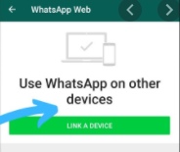

1. SCAN **QR CODE**

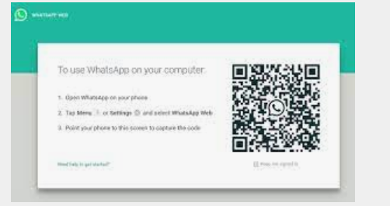

1. **TO DOWNLOAD FILES FROM WHATS APP WEB**

**Click on download icon then it will download into download folder**

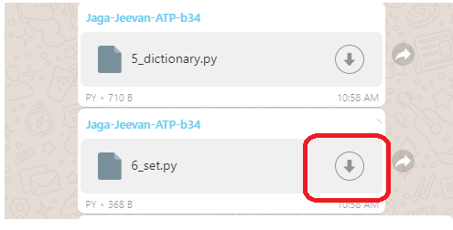

1. **TO OPEN PYTHON FILE IN NOTEPAD ++**

**RIGHT CLICK ON PYTHON FILE** THEN CLICK ON **Edit with Notepad++**

